Decode HR

Server Cronjob Configuration User Guide

Contents

1 Introduction 4

2 Section Summary 5

3 Server cronjob configuration Process 6

3.1 Server cornjob editing and creation 6

3.2 Scheduling Configuration details: 9

3.2.1 Scheduling timing Configuration in python files 9

3.3 Updating cronjob and schedule 10

Table of Figures

Figure 3‑5 : Advance – Cronjob 6

Figure 3‑6 : Cronjob Weekly task configuration option 6

Figure 3‑7 : Scheduling Configuration details 7

Figure 3‑8 : Cronjob listing 8

Figure 3‑9 : Command copy for activation of Python Virtual env 8

Figure 3‑6 : Scheduling Python Code - RunTaskPeriodically 9

Figure 3‑7 : Advance – Terminal 10

Figure 3‑8 : Killing previous cronjob process 10

# Introduction

This is the detail procedures description on how to configure the cronjob in the Server.

# Section Summary

This section is a summary description of each section.

|  |  |
| --- | --- |
| Section | description |
| Linux Cronjob Configuration | Details of how to configure the cronjob scheduling |
|  |  |
|  |  |
|  |  |

# Server cronjob configuration Process

## Server cornjob editing and creation

1. Login to the link : <http://www.dchr.a2hosted.com/cpanel> username : dchrahos / *D9vSD3bFw8()5m*
2. Cronjob
   1. Go to Advance section and click on “Cronjobs” (Either click edit on the exiting cronjob or create a new one)

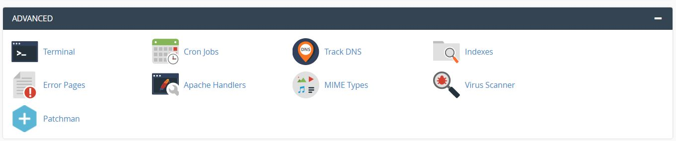

Figure 3‑5 : Advance – Cronjob

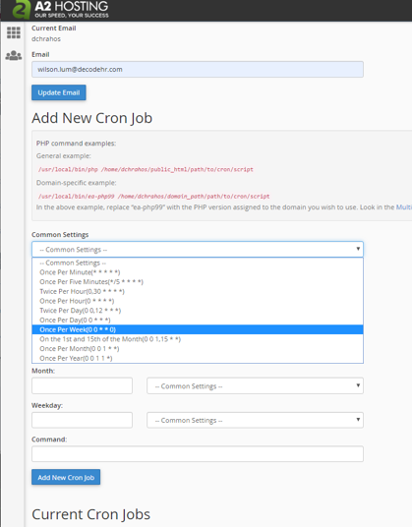

Figure 3‑6 : Cronjob Weekly task configuration option

* 1. With command :   
     source /home/dchrahos/virtualenv/DCHR1/3.7/bin/activate && cd /home/dchrahos/dashboard && python Server_schedule_process.py

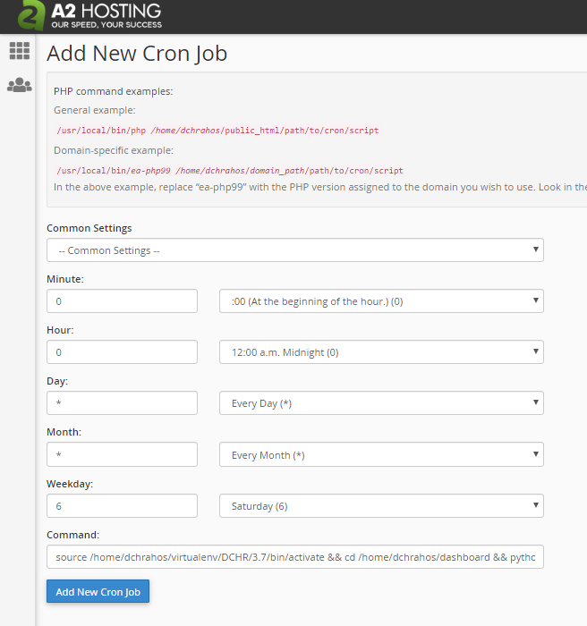

Figure 3‑7 : Scheduling Configuration details

* 1. Cronjob listing:

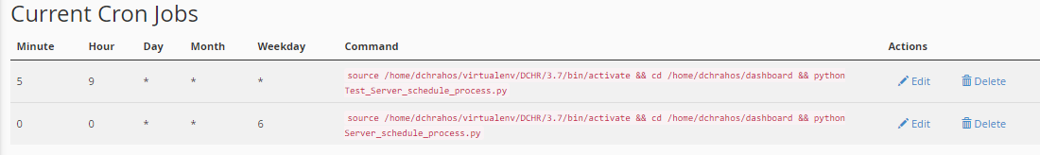

Figure 3‑8 : Cronjob listing

* 1. Take note if the cronjob is edited and reschedule, the previous python process will need to be killed if not the process will take up resources. Use “ps -ef | grep python” to check what is the process id for the previous process and then use “Kill -9 <pid>” to kill the old process
  2. Make sure the cronjob starting timing should be before the first program run in the Server_schedule_process.py in the RunTaskPeriodically() function.

1. Copy the command to use in the terminal command line to activate the python env as show in the next step.

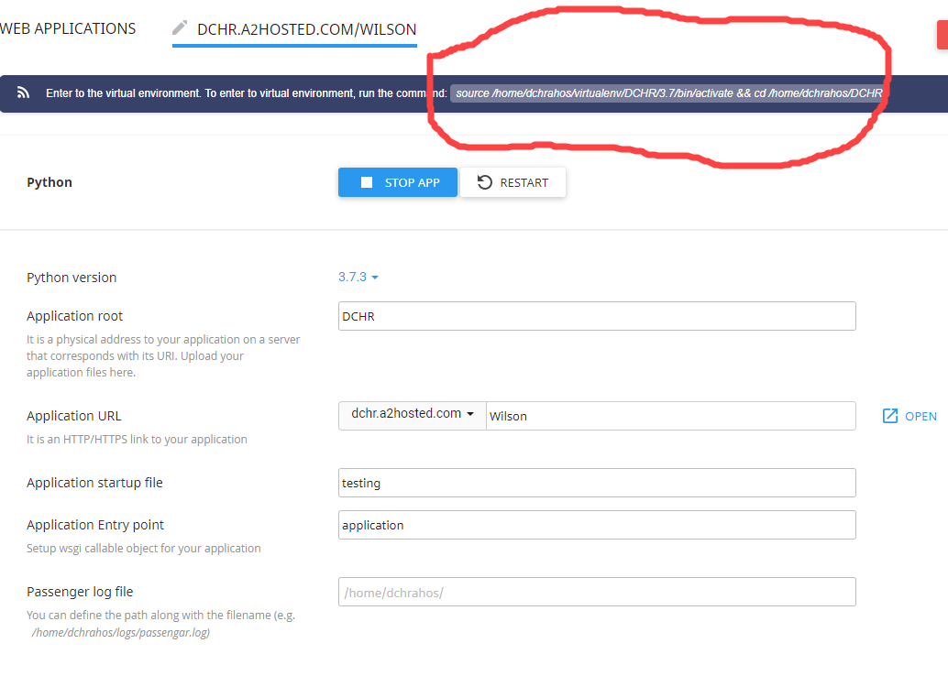

Figure 3‑9 : Command copy for activation of Python Virtual env

## Scheduling Configuration details:

### Scheduling timing Configuration in python files

Generally the timing configuration is similar for both Windows and Linux Platform. For more details of how to amend the timing and day of the scheduling, you can read at the following links:

<https://www.geeksforgeeks.org/python-schedule-library/>

You edit the python code file “Win_schedule_process.py” (Windows) & “Server_process_schedule.py (Linux) and go to the function name RunTaskPeriodically().

Eg. For “schedule.every().monday.at('14:25').do(twitter_by_topic_scrap)” as the first starting program, you can change to :

schedule.every().saturday.at('23:00').do(twitter_by_topic_scrap)

Make sure between each program, this is some time allowance given for the previous program to run. Recommended will be at least 1.5 hours between each program. For Twitter under PC windows with 16G RAM and 6 Core 4.28GHz CPU will only take about 10-15 mins to run. Sometimes it may take extra of 15 mins due to twitter max scrapping and hence require to sleep for 15 mins.

Under server linux platform, it may take longer time depends on the subscription of the Hardware resources. Hence about 1.5 to 2 hours in time difference between each program is recommended.

**Note : Once the schedule timing has changed, make sure the cronjob schedule has to be align and updated and rerun. And previosu cronjob process has tobe killed manually.**

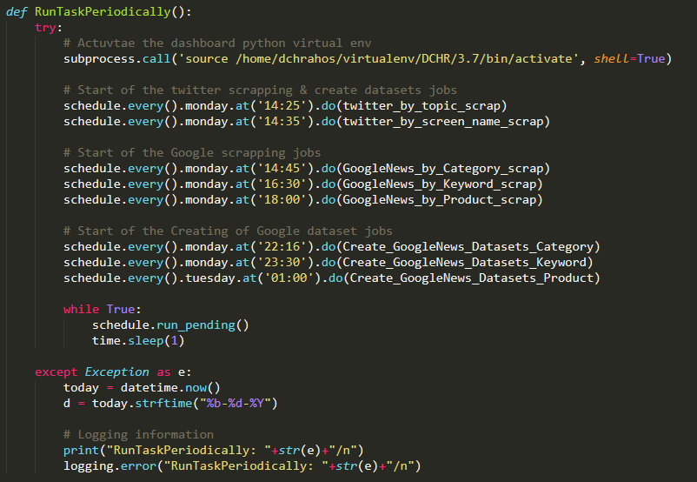

Figure 3‑6 : Scheduling Python Code - RunTaskPeriodically

## Updating cronjob and schedule

Editing and changing the schedule dates and time require both the cronjob and the Server_schedule_process.py to be align in the timing planning. After changes is done, the previous cronjob process is required to be manually killed by the following figures shown.

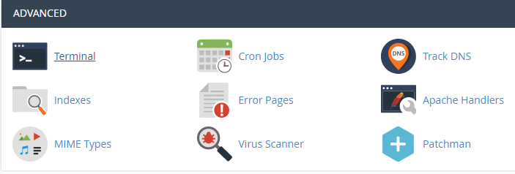

Figure 3‑7 : Advance – Terminal

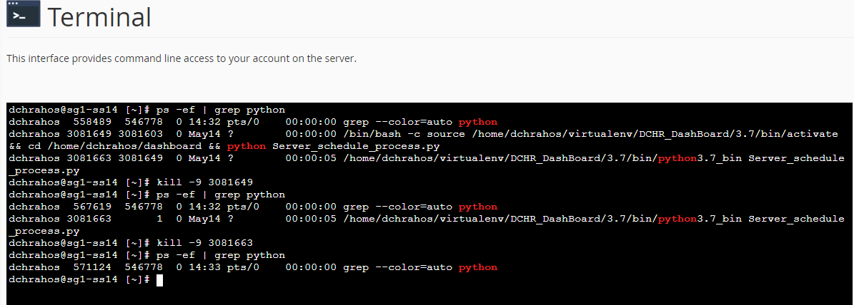

Figure 3‑8 : Killing previous cronjob process